**1. INTRODUCTION**

**The Shopping Website Project is a cutting-edge e-commerce platform designed to enhance the online shopping experience by categorizing products into "Old Products" and "New Products." This structured approach simplifies product discovery, ensuring users can effortlessly browse and purchase items based on their preferences. With a focus on modern design, seamless navigation, and intuitive functionality, the platform caters to both casual shoppers and frequent buyers, making transactions smooth and efficient.**

**By leveraging responsive web technologies and an optimized checkout process, the system not only meets current industry standards but also anticipates future advancements in online retail. This project prioritizes user experience, performance, and scalability, enabling businesses to expand their product offerings while maintaining an engaging and efficient shopping environment. This document provides a comprehensive overview of the system’s specifications, architectural design, key development processes, testing methodologies, deployment strategies, and future enhancements planned to improve the platform further.**

**1.1 Project Rationale and Objectives**

**In the rapidly evolving world of online shopping, many traditional e-commerce platforms struggle to keep up with modern demands. This project seeks to address these challenges by: - **Enhancing User Experience:** By clearly separating product categories into distinct sections for **legacy** and **new products**, users can quickly navigate and find exactly what they're looking for. - **Improving System Performance:** Fast, real-time updates of the shopping cart, efficient management of data with **browser localStorage**, and a streamlined unified checkout system provide users with a smooth, error-free shopping journey. - **Enabling Future Growth:** A flexible, **modular design** ensures that the platform can evolve over time, incorporating features like **user authentication**, **advanced payment options**, and **personalized shopping experiences**. - **Cross-Platform Accessibility:** The platform features a **responsive design** that functions seamlessly across both desktop and mobile devices, broadening its user base and offering an inclusive shopping experience for all. for 7 seconds**

**In an era where online shopping is rapidly evolving, many traditional e-commerce solutions struggle to keep pace with modern consumer expectations and often appear outdated or cluttered. This project directly addresses these challenges by focusing on several key objectives:**

**• Enhance User Experience: The platform creates distinct pages for legacy items and new arrivals, enabling customers to quickly differentiate between product types. This clear separation not only simplifies navigation but also minimizes cognitive overload, resulting in a more intuitive and engaging shopping journey. The design emphasizes user-centric interfaces and streamlined interactions that make finding and purchasing products both enjoyable and efficient.**

**• Improve System Responsiveness: Leveraging real-time cart updates and efficient data handling via browser localStorage, the system ensures that every user action is met with immediate feedback. A unified checkout process eliminates unnecessary steps, reducing delays and potential errors. This responsiveness not only enhances performance under heavy traffic but also builds trust with customers by providing a consistently smooth shopping experience.**

**• Facilitate Future Scalability: The project’s modular architecture is designed with growth in mind. It allows for the seamless integration of future functionalities such as secure user authentication, advanced payment methods, and personalized recommendation systems. By planning for scalability, the platform is prepared to evolve alongside emerging technologies and adapt to changing market trends without requiring a complete overhaul of its core infrastructure.**

**• Support Cross-Platform Functionality: Recognizing that consumers use a variety of devices, the platform employs a responsive design that adapts flawlessly across desktops, tablets, and smartphones. This ensures that every user, regardless of their device, experiences a consistent, accessible, and high-performing interface. The cross-platform approach broadens the potential audience and makes the shopping experience universally accessible.**

**Together, these enhancements create a robust foundation for a next-generation e-commerce solution that not only meets the current demands of online retail but also paves the way for future innovation and sustained user satisfaction.**

**2. SYSTEM SPECIFICATION**

**The project is designed to operate efficiently on standard hardware, while maximizing cross-platform compatibility through contemporary web technologies. The system’s performance is optimized for a range of environments, ensuring both robustness and scalability as user demands increase. ### 2.1 Hardware Specification • **Processor:** The project requires a multi-core CPU, such as an Intel i5 or its equivalent, which is essential for handling multiple concurrent user interactions. This ensures that even with a high volume of customers accessing the platform simultaneously, the system can manage resources effectively to maintain smooth performance. • **Hard Disk Capacity:** At least 500GB of storage is recommended to handle the growing needs of the platform, including the management of static assets, logs, backups, and the potential expansion of future database requirements. This ample storage ensures that the system can quickly scale and accommodate an increasing number of products and user interactions over time. • **Monitor:** A standard HD display, with a minimum size of 14 inches, is essential for development, testing, and debugging purposes. This allows developers to manage multiple windows, inspect code, and conduct quality checks on the user interface while ensuring that all visual elements are accurately displayed. • **Internal Memory:** A minimum of 4GB RAM is required for the smooth operation of core tasks during development, ensuring that multiple tools and applications can run simultaneously without lag. For optimal performance, 8GB of RAM is recommended, providing sufficient memory for more demanding development environments and multitasking scenarios. • **Input Devices:** A standard QWERTY keyboard and either an optical or wireless mouse are crucial for smooth and efficient navigation, code development, and testing. These input devices facilitate easy interaction with both the software and the development tools, enabling unmatched productivity during all stages of project development. These specifications ensure that the project will run effectively under typical development conditions, while also preparing the system for ongoing scalability and future enhancements. The combination of sufficient resources and modern web technologies will create a flexible and adaptable platform capable of meeting evolving user and business needs. for 11 seconds**

**The project is designed to run seamlessly on standard hardware while taking full advantage of modern web technologies to ensure robust cross-platform compatibility. By selecting appropriate hardware components, the system maintains high performance during both development and production, enabling efficient handling of user interactions and data processing. Below are the expanded hardware specifications:**

**2.1 Hardware Specification**

**• Processor:  
A multi-core CPU (e.g., Intel i5 or equivalent) is essential for efficiently managing concurrent user interactions. The multi-core architecture allows the system to process several tasks simultaneously, ensuring that the application remains responsive even when handling complex operations or high traffic volumes.**

**• Hard Disk Capacity:  
A storage capacity of 500GB or more is recommended to effectively manage a variety of needs, including static assets (like images and HTML files), extensive log files, regular backups, and potential future database requirements. This capacity ensures that the system can scale as the volume of data increases over time.**

**• Monitor:  
A standard HD display with a minimum size of 14 inches is required for both development and testing. This specification provides developers with ample screen real estate to comfortably view code, monitor performance metrics, and troubleshoot issues without compromising on visual clarity or productivity.**

**• Internal Memory (RAM):  
The system requires a minimum of 4GB RAM, with 8GB being recommended for a smoother multitasking experience during development. Adequate RAM ensures that multiple applications and development tools (such as IDEs, web browsers, and testing frameworks) can run concurrently without performance degradation, leading to a more efficient workflow.**

**• Input Devices:  
Utilizing standard input devices like a QWERTY keyboard and an optical or wireless mouse is crucial for effective navigation and code development. A reliable keyboard facilitates precise input, while a responsive mouse enables quick navigation through the user interface and development tools, enhancing overall productivity.**

**By adhering to these enhanced hardware specifications, the project is well-equipped to deliver optimal performance and a seamless user experience, ensuring that both developers and end-users benefit from a robust and efficient system.**

**2.2 Software Specification**

**The project’s software environment is carefully crafted to ensure both flexibility and high performance by leveraging modern web technologies and tools. Below is an expanded overview of the software specifications:**

**• Operating System:  
The project is designed for cross-platform compatibility, meaning it can run seamlessly on various operating systems such as Windows 10/11, macOS, and Linux. This versatility allows developers to work in their preferred environment without compatibility issues, and ensures that the end product is accessible to a wide range of users.**

**• Front End:  
At the heart of the user experience is a robust front end built using HTML5, CSS3, and JavaScript. This technology stack provides a solid foundation for creating dynamic, responsive, and visually appealing web pages. Additionally, modern frameworks like Vue.js or React can be incorporated to enhance interactivity and streamline the development of complex user interfaces, ensuring that the platform remains both intuitive and engaging.**

**• Back End / API Integration:  
To maintain a smooth and responsive user journey, the project utilizes browser localStorage to persist cart data, ensuring that users’ selections are retained across different sessions and pages. In conjunction with this, AJAX and the Fetch API are employed for dynamic content updates, allowing the website to refresh parts of the page in real time without requiring a full reload. This approach enhances performance and provides a seamless shopping experience.**

**• Development Tools:  
The development process is supported by industry-standard tools. Visual Studio Code (or a similar Integrated Development Environment) offers a rich coding experience with features like intelligent code completion and debugging support. Git is used for version control, ensuring that code changes are meticulously tracked and managed. Moreover, the project is tested across modern browsers such as Chrome, Firefox, and Edge to guarantee compatibility and optimal performance in diverse environments.**

**• Additional Tools:  
To further refine the development process, browser developer tools are employed for in-depth debugging, performance profiling, and security testing. These tools enable developers to quickly identify and resolve issues, optimize the website's performance, and ensure that security best practices are upheld throughout the project lifecycle.**

**This comprehensive software setup not only supports robust development and efficient testing but also guarantees that the final product is both reliable and scalable across a variety of platforms and user scenarios.**

**3. SYSTEM STUDY**

**In today's competitive e-commerce landscape, many platforms choose to specialize either in legacy product lines or in the latest modern offerings, resulting in a fragmented market. This segmentation often leaves customers without a unified shopping experience that blends both traditional and contemporary products seamlessly.**

**3.1 Analysis of Existing Systems**

**3.1.1 Strengths and Weaknesses**

**Strengths:**

**• Wide Product Listings:  
Many current platforms boast extensive product catalogs, providing a broad selection that caters to diverse consumer needs. These websites typically feature standard shopping carts, making it straightforward for users to add and manage products, albeit within a somewhat static framework.**

**• Robust Back-End Databases:  
By leveraging powerful back-end databases, these systems ensure persistent storage of product information, customer details, and order histories. This robust infrastructure supports reliable data retrieval and management, contributing to overall operational stability.**

**Weaknesses:**

**• Fragmented Navigation:  
A significant drawback of many existing solutions is their disjointed navigation system. Users are often required to switch between multiple pages to access different product categories, which disrupts the shopping experience and increases the likelihood of customer frustration.**

**• Delayed Cart Updates:  
Many platforms suffer from inefficient checkout processes due to delayed cart updates. When a user modifies their cart, the lack of real-time feedback can lead to confusion and errors during checkout, undermining the overall efficiency of the shopping experience.**

**• Lack of Clear Product Differentiation:  
Without a distinct separation between legacy items and new products, these platforms can leave customers unsure about the origins and relevance of the products displayed. This ambiguity may confuse consumers, making it difficult for them to identify which items are part of a trusted, established range and which are cutting-edge or recently introduced.**

**Overall, while existing systems offer certain advantages in terms of product variety and data reliability, the shortcomings in navigation, responsiveness, and product categorization highlight the need for a more integrated and user-centric approach—one that this project aims to deliver.**

**3.2 Proposed System Advantages**

**The Shopping Website Project overcomes the challenges of existing e-commerce platforms by implementing a series of innovative features designed to streamline the shopping experience and enhance overall performance. First, it introduces Dual Product Views, which provide separate, dedicated pages for “Old Products” and “New Products.” This clear segmentation allows customers to quickly identify and navigate between legacy items and the latest offerings, reducing confusion and simplifying product discovery.**

**In addition, the project features Unified Cart Functionality that consolidates items from both product categories into a single, dynamically updated cart. This integration ensures that users can manage their selections without needing to switch between different sections, leading to a smoother, more coherent shopping experience.**

**The Optimized Checkout Process further distinguishes the platform by leveraging browser localStorage and dynamic front-end updates. This approach enables real-time feedback during cart modifications, significantly reducing latency and preventing errors during checkout. By providing immediate visual confirmations and minimizing delays, the checkout process becomes both efficient and reliable.**

**Finally, the project prioritizes an Enhanced User Experience with a clean, responsive user interface. Quick navigation, interactive elements, and intuitive design work together to create an engaging and accessible environment for all users. This comprehensive integration of features not only addresses the limitations of traditional systems but also sets a new standard for modern, user-centric e-commerce solutions.**

**4. DESIGN AND DEVELOPMENT PROCESS**

**The project is built upon a modular, component-based architecture that enhances maintainability, scalability, and performance throughout the development lifecycle. This design strategy is rooted in several key principles:**

**• Separation of Concerns:  
By clearly dividing the project into HTML for structure, CSS for presentation, and JavaScript for behavior, each layer can be developed and managed independently. This separation not only simplifies debugging and updates but also ensures that each aspect of the application is optimized for its specific role.**

**• Modularity:  
Each functional component of the website—such as the home page, product listings, shopping cart, and checkout process—is developed, tested, and integrated as an independent module. This modular approach allows for easier maintenance and upgrades, as individual modules can be modified without affecting the entire system.**

**• Responsiveness:  
The design is inherently responsive, adapting seamlessly to a wide range of screen sizes and devices. This ensures that users enjoy a consistent, high-quality experience whether they are browsing on a desktop, tablet, or smartphone.**

**• Reusability:  
The project leverages reusable components and functions, which helps to reduce code redundancy and enhances overall maintainability. By reusing well-defined components, developers can streamline updates and reduce the potential for errors, thereby accelerating the development process while ensuring consistency across the application.**

**Together, these fundamental design concepts create a robust framework that not only addresses current requirements but also positions the platform for future growth and adaptability.**

**4.2 Detailed Input and Output Design**

**4.2.1 Input Design**

**The design of the input interface is structured to ensure that every user interaction is both intuitive and efficient. Key aspects include:**

**• User Selections:  
Actions such as clicking buttons to increase or decrease product quantities are seamlessly integrated, allowing users to modify their orders effortlessly.**

**• Navigation Actions:  
Interactive menus and links facilitate smooth transitions between different pages, ensuring that users can easily explore various sections of the website.**

**• Form Inputs:  
Looking ahead, the design anticipates the inclusion of registration and payment forms. These inputs will incorporate robust client-side validation to maintain data integrity and ensure that only valid information is processed.**

**• Accessibility Considerations:  
The input design adheres to accessibility standards by incorporating ARIA labels, keyboard navigability, and screen reader support. These measures guarantee that the platform is usable by all individuals, including those with disabilities.**

**4.2.2 Output Design**

**The output design focuses on providing immediate, clear, and dynamic feedback to enhance the overall user experience. Key elements include:**

**• Dynamic Product Listings:  
The platform displays comprehensive product information including images, detailed descriptions, pricing, discounts, and availability indicators. This dynamic display ensures that users are well-informed about each product.**

**• Real-Time Cart Updates:  
Visual feedback is provided whenever a user updates their cart. This includes real-time changes to the total pricing and item counts, ensuring that users are always aware of their current selections.**

**• Order Confirmation:  
After completing a purchase, users receive clear and unambiguous confirmation messages. These messages include detailed order information and any necessary follow-up actions to guide the next steps.**

**• Responsive Feedback:  
The design incorporates visual cues such as animations, hover states, and error messages. These responsive elements help guide users through their interactions, providing immediate feedback that enhances the overall navigation and usability of the website.**

**This comprehensive input and output design framework ensures that every user action is met with precise, real-time feedback, creating an engaging and accessible shopping experience.**

**4.3 Architectural and Code Design**

**4.3.1 Architectural Overview**

**• Front-End Architecture:  
The project employs a modern, component-based framework to construct the user interface. Each UI element—whether it's a header, footer, product card, or interactive widget—is developed as an isolated, reusable component. This approach not only streamlines development by promoting code reuse but also simplifies maintenance and future enhancements by allowing individual components to be updated or replaced without impacting the entire system.**

**• Data Flow:  
To ensure a seamless and responsive user experience, the application utilizes browser localStorage to maintain the state of the shopping cart across page navigations. This client-side storage is complemented by JavaScript’s Fetch API, which provides a flexible means for server-side interactions when necessary. This combination allows for smooth data persistence and dynamic content updates, reducing the need for full page reloads and ensuring that user actions are reflected in real time.**

**• Scalability:  
The architectural design is forward-thinking, with scalability built into the core framework. It anticipates future enhancements such as the integration of third-party APIs and the incorporation of real-time databases. This design flexibility ensures that the platform can grow and adapt to increasing user demands and evolving technological standards without necessitating major architectural overhauls.**

**4.3.2 Code Organization**

**• Semantic HTML:  
The project utilizes semantic HTML to structure its content, enhancing both search engine optimization (SEO) and accessibility. By using meaningful HTML tags, the code provides context to browsers and assistive technologies, ensuring that the content is both easily indexable and accessible to users with disabilities.**

**• Modular CSS:  
CSS is organized using modular methodologies such as the Block Element Modifier (BEM) approach. This methodical structuring of styles not only ensures a maintainable and scalable codebase but also minimizes the risk of style conflicts. Modular CSS allows for consistent styling across components and simplifies updates as the project evolves.**

**• JavaScript Patterns:  
Following established best practices, the JavaScript code is structured around design patterns like the Model-View-Controller (MVC). This separation of concerns distinguishes the business logic from the user interface, resulting in a more organized and maintainable codebase. By adhering to these patterns, the project ensures that code is easier to debug, extend, and collaborate on, contributing to the overall robustness of the application.**

**This architectural and code design framework lays a solid foundation for building a high-performance, scalable, and maintainable e-commerce platform that is well-prepared to meet both current and future challenges.**

**5. DEVELOPMENT APPROACH**

**5.1 Top-Down Approach**

**The project employs a top-down methodology to build a robust framework that guides the entire development process. This approach ensures that the overarching design and navigation are established from the outset, providing a clear blueprint for incremental enhancements.**

**• Core Application Layout:  
Development begins with creating a comprehensive design and navigation framework that sets the stage for all subsequent features. This foundational layout ensures consistency in user experience and acts as the backbone for module integration.**

**• Incremental Integration:  
Individual modules—such as the home page, product listings, cart, and checkout—are integrated gradually into the core framework. This step-by-step approach ensures seamless interaction and efficient data flow between components, making it easier to identify and resolve issues during integration.**

**• Iterative Testing:  
At every development phase, rigorous testing is conducted through unit tests, integration tests, and system tests. This iterative testing process helps in early detection of bugs and performance issues, ensuring that each module works as expected before full-scale integration.**

**• User Feedback Loop:  
Incorporating early and ongoing user testing allows the development team to refine the interface continuously. By gathering and analyzing user feedback, usability issues can be promptly addressed, resulting in a more intuitive and user-friendly final product.**

**5.2 Agile Methodologies and Version Control**

**To complement the top-down approach, the project also embraces agile methodologies and robust version control practices to maintain flexibility, ensure quality, and support continuous improvement.**

**• Agile Development:  
The project is organized into agile sprints, with daily stand-ups and regular retrospectives. This agile framework encourages rapid development cycles, adaptability to changing requirements, and a focus on continuous improvement, ensuring that the project evolves in a responsive and efficient manner.**

**• Version Control:  
Using Git as the primary version control system allows for meticulous management of code changes. Branching for new features and maintaining a detailed commit history facilitate seamless collaboration, easy rollback of changes if necessary, and overall project organization.**

**• Code Reviews:  
Regular peer code reviews are integral to the development process. These reviews help ensure that coding standards are maintained, bugs are caught early, and the codebase remains clean and efficient. This collaborative practice not only improves code quality but also fosters knowledge sharing among team members.**

**Together, these development strategies—anchored by a top-down approach and enhanced by agile practices and rigorous version control—form a robust framework that drives the project's success while ensuring high standards of quality, adaptability, and user satisfaction.**

**6. TESTING AND QUALITY ASSURANCE**

**The project prioritizes a rigorous testing and quality assurance framework to ensure a stable, secure, and user-friendly shopping experience. This framework encompasses multiple testing strategies and quality assurance processes designed to catch issues early, verify system integrity, and maintain high performance throughout the development cycle.**

**6.1 Testing Strategies**

**6.1.1 Unit Testing**

**• Component-Level Testing:  
Individual components—such as functions for adjusting product quantities and updating the cart via localStorage—are thoroughly tested using frameworks like Jest or Mocha. This ensures that each component performs as expected in isolation.**

**• Automated Testing:  
Automated tests are implemented to cover regression scenarios and integration points. These tests run on a continuous basis, enabling rapid detection of any inadvertent changes or errors in functionality across updates.**

**6.1.2 Integration Testing**

**• Module Interactions:  
The interactions between different modules—such as product listings, cart updates, and the checkout process—are verified to ensure seamless data flow and coordinated behavior across the system.**

**• End-to-End Testing:  
Tools like Selenium or Cypress are used to simulate real user interactions, testing the entire shopping journey from browsing to checkout. This comprehensive approach ensures that the overall experience is cohesive and functions correctly under various conditions.**

**6.1.3 User Acceptance Testing (UAT)**

**• Focus Group Testing:  
Feedback is gathered from real users through focus groups to assess the usability, intuitiveness, and overall satisfaction with the platform. This qualitative input helps refine the user interface and interaction flow.**

**• Beta Testing:  
A beta version of the platform is released to a limited audience, allowing developers to collect performance metrics, error logs, and user feedback in a controlled environment before full-scale deployment.**

**6.2 Performance and Security Testing**

**• Performance Testing:  
Performance is evaluated using tools such as Lighthouse and GTmetrix to measure load times, responsiveness, and overall efficiency. These tests help identify and address performance bottlenecks before the product reaches a wider audience.**

**• Security Testing:  
The system undergoes thorough vulnerability scanning and penetration testing to ensure resilience against common web attacks, including Cross-Site Scripting (XSS) and Cross-Site Request Forgery (CSRF). This proactive approach helps safeguard user data and maintain trust.**

**• Cross-Browser Testing:  
The website is tested across a variety of browsers and devices to ensure consistent performance and user experience. This ensures that the platform is accessible and functions reliably regardless of the user's chosen environment.**

**6.3 Quality Assurance Processes**

**• Continuous Integration/Continuous Deployment (CI/CD):  
Automated pipelines for testing and deployment are established to enable rapid, reliable updates. CI/CD practices ensure that each code change is systematically tested and integrated, reducing the risk of introducing new issues during deployment.**

**• Code Reviews and Audits:  
Regular peer reviews and code audits are conducted to maintain high coding standards, optimize performance, and enhance security. These practices help identify potential issues early and promote a culture of continuous improvement among the development team.**

**By combining these comprehensive testing strategies with robust quality assurance processes, the project is well-equipped to deliver a stable, high-performance, and secure e-commerce platform that meets both developer and user expectations.**

**7. SYSTEM IMPLEMENTATION**

**The system implementation phase is critical to transitioning from design to a fully functional e-commerce platform. This phase encompasses both the technical procedures for building the application and the creation of comprehensive documentation to ensure smooth operation, maintenance, and future development.**

**7.1 Implementation Procedures**

**• Prototype Development:  
The initial step involves developing a working prototype using HTML, CSS, and JavaScript. This prototype is used to validate the core functionalities of the platform, allowing the team to assess the design, layout, and basic interactivity before full-scale development begins.**

**• Incremental Module Integration:  
Once the prototype is validated, individual modules—such as the home page, product listings, cart, and checkout—are gradually merged into the overall system. This incremental integration is coupled with continuous testing to ensure that data flows smoothly and that user interactions remain consistent as new features are added.**

**• Debugging and Optimization:  
During the integration process, browser development tools and performance profilers are utilized to identify and resolve any bottlenecks or issues. This step focuses on refining the codebase, optimizing load times, and ensuring that the system operates efficiently across various devices and browsers.**

**• Deployment:  
After thorough testing and optimization, the final product is deployed on a secure web server. This deployment includes the use of HTTPS encryption to protect data in transit, as well as load balancing strategies to ensure high availability and scalability, even under heavy traffic conditions.**

**7.2 Operational Documentation**

**To support both end users and future developers, comprehensive operational documentation is created:**

**• User Manual:  
A detailed guide is provided to explain how users can navigate the website, manage their shopping cart, and complete the checkout process. This manual includes step-by-step instructions, screenshots, and troubleshooting tips to ensure a smooth and intuitive user experience.**

**• Developer Guide:  
For the development team and future maintainers, a technical document is prepared that covers the code structure, integration points, and overall system architecture. This guide offers insights into the development process, best practices, and instructions for adding new features or modifying existing ones.**

**• Maintenance Plan:  
A well-defined maintenance plan outlines the procedures for updating content, applying security patches, and implementing new features with minimal downtime. This plan ensures that the system remains secure, up-to-date, and capable of adapting to evolving technological requirements and market demands.**

**By following these implementation procedures and establishing thorough operational documentation, the project is positioned for a successful launch and sustained performance, while also providing a clear roadmap for future enhancements and maintenance.**

**8. TEAM ROLES, PROJECT TIMELINE, AND RISK MANAGEMENT**

**This section outlines the organizational structure, project milestones, and risk management strategies critical for ensuring the project's success. By clearly defining team roles, establishing a detailed timeline, and planning for potential challenges, the project is well-prepared to meet its objectives efficiently and effectively.**

**8.1 Team Roles and Responsibilities**

**A clearly defined team structure helps distribute tasks effectively and ensures that each aspect of the project is managed by specialists:**

**• Project Manager:  
Responsible for overseeing the entire project, the Project Manager coordinates timelines, manages resource allocation, and maintains clear communication with stakeholders. This role ensures that project milestones are met on schedule and that any issues are promptly addressed.**

**• Front-End Developers:  
These developers focus on creating the responsive user interface. Their responsibilities include implementing interactive features, ensuring cross-browser compatibility, and optimizing the client-side experience. They play a critical role in ensuring that the website is both visually appealing and functionally robust.**

**• Back-End Developers:  
Tasked with developing and maintaining server-side APIs, back-end developers integrate third-party services and manage data persistence. Their work ensures that the application’s core functions, such as data retrieval and storage, operate reliably and securely.**

**• QA Engineers:  
Quality Assurance Engineers design and execute comprehensive testing strategies. They are responsible for conducting unit tests, integration tests, and performance assessments to guarantee the system's reliability and overall performance. Their proactive testing helps identify and resolve potential issues early in the development cycle.**

**• UI/UX Designers:  
These designers create intuitive and user-friendly designs and prototypes, ensuring that the interface meets accessibility standards. Their work is essential for providing a seamless user experience, balancing aesthetics with functional requirements to cater to a diverse audience.**

**8.2 Project Timeline and Milestones**

**A well-structured timeline with clearly defined phases is crucial for tracking progress and ensuring timely project delivery:**

**• Phase 1: Planning and Prototyping:  
This initial phase involves gathering requirements, creating initial design mockups, and developing a prototype. The goal is to establish a clear vision and validate core functionalities before moving forward with full-scale development.**

**• Phase 2: Module Development:  
In this phase, the focus shifts to building and integrating core modules such as the home page, product listings, cart, and checkout. Each module is developed incrementally, allowing for focused testing and ensuring that every component meets its functional requirements.**

**• Phase 3: Testing and Feedback:  
Comprehensive testing is conducted during this phase, including unit, integration, performance, and security tests. Additionally, beta testing is carried out with real users to gather feedback, allowing the team to refine the platform and address any usability or performance issues.**

**• Phase 4: Deployment and Monitoring:  
The final phase involves deploying the fully integrated system on a secure web server, followed by post-launch monitoring. Continuous monitoring and iterative improvements ensure that the platform remains robust, secure, and responsive to user needs over time.**

**8.3 Risk Management and Mitigation**

**Proactive risk management is essential to safeguard the project against potential issues and ensure smooth execution:**

**• Risk Identification:  
Potential risks are identified early, including challenges related to browser compatibility, security vulnerabilities, and performance bottlenecks. By recognizing these issues in advance, the team can develop strategies to address them before they escalate.**

**• Mitigation Strategies:  
To minimize risks, the project incorporates thorough testing regimes, regular code reviews, and the application of proven security practices. These strategies help to catch and resolve issues early, thereby maintaining system integrity and performance throughout the development process.**

**• Contingency Planning:  
In addition to proactive measures, the project establishes contingency plans such as backup systems and roll-back strategies. These plans are designed to quickly address any unexpected failures, ensuring that the project can recover swiftly with minimal disruption to service.**

**Together, these detailed plans for team roles, project timelines, and risk management form a comprehensive framework that supports the project's overall success, ensuring that all aspects of development and deployment are carefully managed and that any potential challenges are effectively mitigated.**

**9. PERFORMANCE, SECURITY, AND ACCESSIBILITY**

**Ensuring a fast, secure, and accessible platform is crucial for delivering a high-quality user experience. The project incorporates comprehensive strategies to optimize performance, safeguard data, and promote inclusivity.**

**9.1 Performance Optimization**

**• Front-End Optimization:  
To enhance loading speeds and overall responsiveness, the project minimizes CSS and JavaScript files, compresses images, and implements lazy loading. These techniques reduce file sizes and delay the loading of non-critical resources until needed, ensuring that users experience a swift and efficient interface.**

**• Caching Strategies:  
Browser caching and Content Delivery Networks (CDNs) are employed to store and deliver content quickly. Caching enables the reuse of frequently accessed resources, while CDNs distribute assets globally, reducing latency and load times regardless of the user's location.**

**• Efficient Data Handling:  
The system optimizes localStorage usage to maintain a responsive and persistent user experience without compromising performance. Additionally, the design is flexible enough to allow for future migration to a more robust back-end solution if higher data demands necessitate it.**

**9.2 Security Considerations**

**• Data Encryption:  
Data security is ensured through HTTPS, which encrypts data in transit. Sensitive information is further protected by encryption methods, safeguarding user data from unauthorized access.**

**• Input Validation:  
Strict client-side and server-side validations are implemented to prevent malicious activities like script injection. This dual-layer validation ensures that only well-formed, safe data is processed, reducing the risk of security breaches.**

**• Regular Audits:  
The system undergoes periodic security audits and penetration tests to proactively identify and mitigate vulnerabilities. These regular assessments help maintain a secure environment and ensure compliance with best practices.**

**• User Authentication:  
Future plans include integrating advanced user authentication mechanisms such as secure login systems, multi-factor authentication, and robust session management, thereby adding extra layers of protection to user accounts.**

**9.3 Accessibility and SEO**

**• Accessibility:  
Adhering to WCAG guidelines, the design ensures proper contrast ratios, provides alternative text for images, and supports full keyboard navigability. These measures make the platform accessible to users with diverse needs, including those with disabilities.**

**• SEO Best Practices:  
The project utilizes semantic HTML, well-structured meta tags, and structured data to improve search engine rankings. Coupled with performance enhancements, these practices ensure that the website is both discoverable and user-friendly.**

**• Analytics Integration:  
By integrating analytics tools to monitor user behavior and accessibility metrics, the platform continuously refines the user experience. This data-driven approach allows for ongoing adjustments to meet evolving user needs and maintain optimal performance.**

**Collectively, these strategies ensure that the platform delivers a fast, secure, and accessible experience while also laying the groundwork for future scalability and enhancements.**

**10. DEPLOYMENT, MONITORING, AND MAINTENANCE**

**10.1 Deployment Strategy**

**• Staging Environment:  
Before the website is made public, a dedicated staging environment is used for final testing. This controlled setting replicates the production environment, enabling the team to validate functionalities, ensure stability, and catch any remaining issues without affecting live users.**

**• CI/CD Pipeline:  
Automated Continuous Integration and Continuous Deployment (CI/CD) pipelines are implemented using tools such as Jenkins, GitHub Actions, or GitLab CI. These pipelines streamline the process of testing, integrating, and deploying code updates, ensuring that changes are rapidly and reliably pushed to production while minimizing human error.**

**• Rollout Plan:  
The deployment strategy includes a gradual rollout of the website. This phased approach allows for continuous monitoring of performance and user feedback, ensuring that any potential issues are addressed promptly. By rolling out features incrementally, the team can maintain overall stability and make adjustments as necessary.**

**10.2 Monitoring and Maintenance**

**• Real-Time Monitoring:  
Performance monitoring tools like New Relic or Datadog are employed to continuously track key metrics such as uptime, response times, and error logs. Real-time monitoring allows the team to quickly identify and resolve issues, ensuring a smooth and uninterrupted user experience.**

**• Maintenance Schedule:  
Regular maintenance is scheduled to update software dependencies, apply security patches, and optimize the codebase based on performance data and user feedback. This proactive approach helps keep the system secure, efficient, and up-to-date with evolving technologies.**

**• Documentation Updates:  
Operational and developer documentation is kept current to reflect any changes or new features. Up-to-date documentation ensures that both current and future team members can easily understand the system architecture, deployment procedures, and maintenance routines, facilitating smooth transitions and ongoing feature enhancements.**

**This comprehensive deployment, monitoring, and maintenance framework ensures that the website not only launches successfully but continues to perform optimally and securely over time.**

**11. FUTURE ENHANCEMENT AND EXPANSION**

**The project is built with scalability and forward-thinking innovation at its core, ensuring that it can adapt to evolving market trends and user expectations. To further enrich the platform and broaden its capabilities, several future enhancements are planned:**

**• User Accounts and Profiles:  
In the future, customers will have the ability to register and create personalized profiles. This feature will enable them to track their orders, manage wishlists, and access tailored recommendations, fostering a more engaging and loyal user community.**

**• Advanced Payment Integration:  
To accommodate a wider array of customer preferences, the platform will integrate support for multiple payment methods. This includes the incorporation of digital wallets, cryptocurrencies, and installment plans, providing flexibility and convenience during the checkout process.**

**• Personalized Recommendations:  
Leveraging machine learning algorithms, the system will analyze individual shopping behaviors to deliver personalized product suggestions. This tailored approach is aimed at enhancing the shopping experience by presenting users with items that align closely with their interests and past interactions.**

**• Mobile Application Development:  
Recognizing the growing importance of mobile commerce, there are plans to extend the website’s functionality into native applications for iOS and Android. This expansion will provide users with an optimized, on-the-go shopping experience, ensuring seamless interaction across all devices.**

**• Internationalization:  
To support global expansion, the platform will offer multi-language support and regional customization. This enhancement will enable the website to cater to diverse audiences and adapt to various cultural and market-specific requirements, thereby opening up new international markets.**

**• Advanced Filtering and Search:  
Future updates will include the implementation of comprehensive filtering options, allowing users to sort products by price, category, rating, and other relevant attributes. Additionally, an intelligent search engine will be developed to provide accurate and efficient search results, making it easier for customers to find exactly what they need.**

**• Social Media Integration:  
Enhancing customer engagement further, the platform will integrate social media features such as sharing tools, user reviews, and collaborative marketing campaigns. This integration will not only help in building a vibrant online community but also drive organic traffic and boost overall brand presence.**

**Collectively, these enhancements are designed to transform the platform into a dynamic and versatile e-commerce solution that not only meets current user needs but is also well-prepared for future market challenges and opportunities.**

**12. BIBLIOGRAPHY**

**Website References**

* [**https://developer.mozilla.org/en-US/docs/Web/Guide/HTML/HTML5**](https://developer.mozilla.org/en-US/docs/Web/Guide/HTML/HTML5)
* [**https://developer.mozilla.org/en-US/docs/Web/CSS**](https://developer.mozilla.org/en-US/docs/Web/CSS)
* [**https://developer.mozilla.org/en-US/docs/Web/JavaScript**](https://developer.mozilla.org/en-US/docs/Web/JavaScript)

**Books & Online Resources**

* **“HTML & CSS: Design and Build Websites” by Jon Duckett**
* **“JavaScript: The Good Parts” by Douglas Crockford**
* **Various online tutorials and documentation on modern e-commerce web development practices**

**13. APPENDIX**

**13.1 Data Flow Diagrams (DFD)**

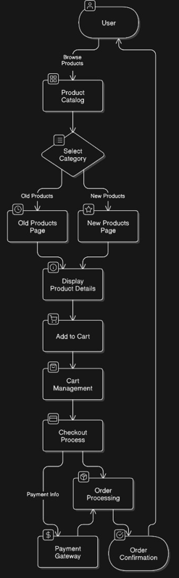

**13.2 Table Structure**

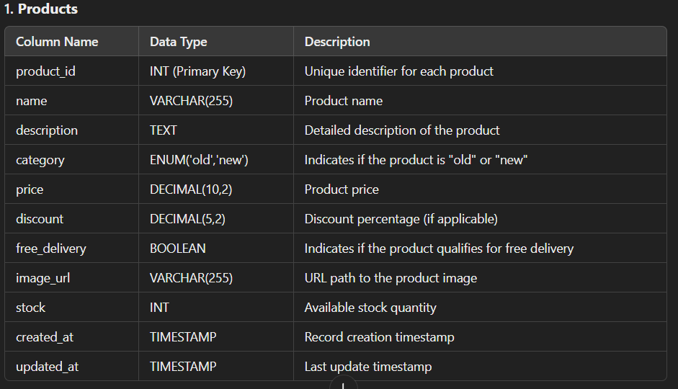

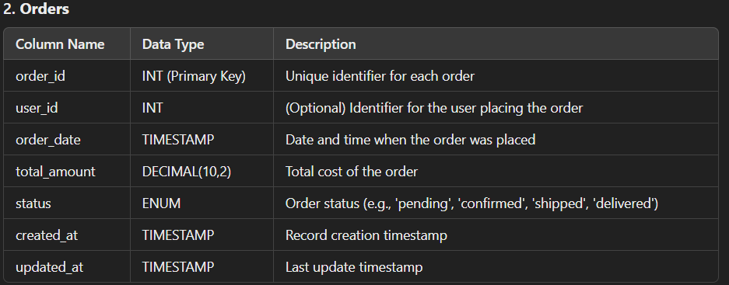

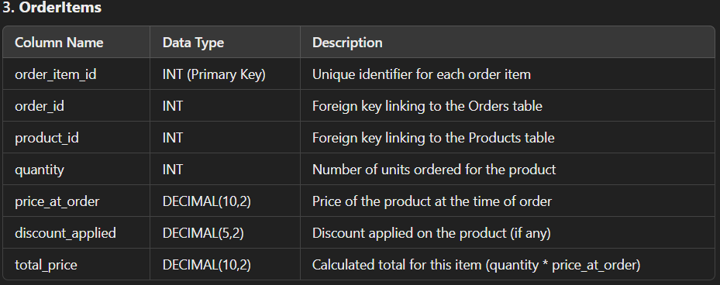

**13.3 Sample Code Snippets**

**Index.html**

<!DOCTYPE html>

<html lang="en">

<head>

    <meta charset="UTF-8">

    <meta name="viewport" content="width=device-width, initial-scale=1.0">

    <title>Shopping Website</title>

    <style>

        body {

            font-family: Arial, sans-serif;

            margin: 0;

            padding: 0;

            background-color: #f4f4f9;

            position: relative;

            overflow: hidden;

        }

        .video-bg {

            position: fixed;

            top: 0;

            left: 0;

            width: 100%;

            height: 100%;

            object-fit: cover;

            z-index: -1;

        }

        .container {

            text-align: center;

            padding: 50px;

            position: relative;

            color: white;

            z-index: 1;

        }

        .container h1 {

            color: black;

        }

        .options {

            display: flex;

            justify-content: center;

            gap: 20px;

            margin-top: 30px;

        }

        .option {

            background-color: #6c5ce7;

            color: white;

            padding: 20px 40px;

            border-radius: 10px;

            text-decoration: none;

            font-size: 20px;

            transition: background-color 0.3s;

        }

        .option:hover {

            background-color: #4834d4;

        }

    </style>

</head>

<body>

    <video autoplay muted loop class="video-bg">

        <source src="./bgvideo.mp4" type="video/mp4">

        Your browser does not support the video tag.

    </video>

    <div class="container">

        <h1>Welcome to the Shopping Website</h1>

        <div class="options">

            <a href="./old-products.html" class="option">Old Products</a>

            <a href="./new-products.html" class="option">New Products</a>

        </div>

    </div>

</body>

</html>

**Old-Product.html**

<!DOCTYPE html>

<html lang="en">

<head>

    <meta charset="UTF-8">

    <meta name="viewport" content="width=device-width, initial-scale=1.0">

    <title>Shopping Website</title>

    <style>

        body {

            font-family: Arial, sans-serif;

            margin: 0;

            padding: 0;

            background-color: #f4f4f9;

        }

        /* Navbar Styles */

        .navbar {

            background-color: #000;

            color: white;

            padding: 15px 20px;

            display: flex;

            justify-content: space-between;

            align-items: center;

        }

        .navbar a {

            color: white;

            text-decoration: none;

            margin: 0 15px;

            font-size: 18px;

        }

        .navbar a:hover {

            color: #e74c3c;

        }

        .container {

            padding: 20px;

            max-width: 1200px;

            margin: auto;

        }

        .product {

            display: flex;

            border: 1px solid #ddd;

            border-radius: 10px;

            background-color: white;

            margin-bottom: 20px;

            padding: 15px;

            box-shadow: 0 4px 8px rgba(0, 0, 0, 0.1);

            align-items: center;

        }

        .product img {

            width: 200px;

            height: 120px;

            border-radius: 10px;

            margin-right: 20px;

            object-fit: cover;

            cursor: pointer;

        }

        .product-details {

            flex-grow: 1;

        }

        .product-title {

            font-size: 18px;

            font-weight: bold;

            color: #2d3436;

            margin: 0;

        }

        .price-section {

            text-align: right;

            margin-left: auto;

        }

        .current-price {

            font-size: 20px;

            font-weight: bold;

            color: #e74c3c;

        }

        .original-price {

            font-size: 16px;

            color: #bdc3c7;

            text-decoration: line-through;

        }

        .discount {

            font-size: 16px;

            color: #27ae60;

            margin-left: 5px;

        }

        .free-delivery {

            font-size: 14px;

            color: #16a085;

            font-weight: bold;

        }

        .quantity-control {

            display: flex;

            align-items: center;

            margin-top: 10px;

        }

        .quantity-control button {

            background-color: #ddd;

            border: none;

            padding: 5px 10px;

            cursor: pointer;

            font-size: 18px;

        }

        .quantity-control span {

            font-size: 18px;

            margin: 0 10px;

        }

        .cart {

            margin-top: 30px;

            padding: 15px;

            border-radius: 10px;

            background-color: white;

            box-shadow: 0 4px 8px rgba(0, 0, 0, 0.1);

        }

        .cart h2 {

            margin-top: 0;

        }

        .cart-items {

            list-style: none;

            padding: 0;

        }

        .cart-items li {

            display: flex;

            justify-content: space-between;

            padding: 10px 0;

            border-bottom: 1px solid #ddd;

        }

        .total-price {

            font-size: 20px;

            font-weight: bold;

            color: #e74c3c;

            margin-top: 10px;

            text-align: right;

        }

        .empty-cart {

            text-align: center;

            font-size: 16px;

            color: #888;

            font-style: italic;

        }

        .checkout-button {

            background-color: #000;

            color: white;

            border: none;

            padding: 10px 20px;

            font-size: 16px;

            cursor: pointer;

            border-radius: 5px;

            margin-top: 20px;

            width: 100%;

        }

        .checkout-button:hover {

            background-color: #333;

        }

        .order-summary {

            margin-top: 20px;

            padding: 15px;

            border-radius: 10px;

            background-color: white;

            box-shadow: 0 4px 8px rgba(0, 0, 0, 0.1);

        }

        .order-summary h3 {

            margin-top: 0;

        }

        .place-order-button {

            background-color: #27ae60;

            color: white;

            border: none;

            padding: 10px 20px;

            font-size: 16px;

            cursor: pointer;

            border-radius: 5px;

            margin-top: 20px;

            width: 100%;

        }

        .place-order-button:hover {

            background-color: #2ecc71;

        }

        .order-confirmation {

            text-align: center;

            font-size: 18px;

            color: #27ae60;

            margin-top: 20px;

        }

    </style>

</head>

<body>

    <!-- Navbar -->

    <div class="navbar">

        <div>

            <a href="./First_page.html">Home</a>

            <a href="./new-products.html">New Product</a>

        </div>

    </div>

    <!-- Product List -->

    <div class="container">

        <h1>Old Product List</h1>

        <div class="products-container">

            <!-- Existing Products -->

            <div class="product" data-name="Fog Lamp Front Right" data-price="2000" data-discount="20">

                <img src="./Fog Lamp Front Right.png" alt="Fog Lamp">

                <div class="product-details">

                    <p class="product-title">Fog Lamp Front Right</p>

                    <p class="current-price">₹2,000</p>

                    <p>

                        <span class="discount">20% off</span>

                    </p>

                    <p class="free-delivery">Free Delivery</p>

                    <div class="quantity-control">

                        <button class="decrease">−</button>

                        <span class="quantity">0</span>

                        <button class="increase">+</button>

                    </div>

                </div>

            </div>

            <div class="product" data-name="Front Brake Disc" data-price="3500" data-discount="25">

                <img src="./Front Brake Disc-Brake Disc.png" alt="Brake Disc">

                <div class="product-details">

                    <p class="product-title">Front Brake Disc</p>

                    <p class="current-price">₹3,500</p>

                    <p>

                        <span class="discount">25% off</span>

                    </p>

                    <p class="free-delivery">Free Delivery</p>

                    <div class="quantity-control">

                        <button class="decrease">−</button>

                        <span class="quantity">0</span>

                        <button class="increase">+</button>

                    </div>

                </div>

            </div>

            <div class="product" data-name="Fog Lamp Front Left" data-price="2000" data-discount="20">

                <img src="./Fog Lamp Front Right.png" alt="Fog Lamp">

                <div class="product-details">

                    <p class="product-title">Fog Lamp Front Left</p>

                    <p class="current-price">₹2,000</p>

                    <p>

                        <span class="discount">20% off</span>

                    </p>

                    <p class="free-delivery">Free Delivery</p>

                    <div class="quantity-control">

                        <button class="decrease">−</button>

                        <span class="quantity">0</span>

                        <button class="increase">+</button>

                    </div>

                </div>

            </div>

            <!-- Additional Products -->

            <div class="product" data-name="Car Battery" data-price="5000" data-discount="15">

                <img src="./Car Battery.webp" alt="Car Battery">

                <div class="product-details">

                    <p class="product-title">Car Battery</p>

                    <p class="current-price">₹5,000</p>

                    <p>

                        <span class="discount">15% off</span>

                    </p>

                    <p class="free-delivery">Free Delivery</p>

                    <div class="quantity-control">

                        <button class="decrease">−</button>

                        <span class="quantity">0</span>

                        <button class="increase">+</button>

                    </div>

                </div>

            </div>

            <div class="product" data-name="Engine Oil" data-price="1200" data-discount="10">

                <img src="./engine-oil.webp" alt="Engine Oil">

                <div class="product-details">

                    <p class="product-title">Engine Oil</p>

                    <p class="current-price">₹1,200</p>

                    <p>

                        <span class="discount">10% off</span>

                    </p>

                    <p class="free-delivery">Free Delivery</p>

                    <div class="quantity-control">

                        <button class="decrease">−</button>

                        <span class="quantity">0</span>

                        <button class="increase">+</button>

                    </div>

                </div>

            </div>

            <div class="product" data-name="Air Filter" data-price="800" data-discount="5">

                <img src="./air-filter.webp" alt="Air Filter">

                <div class="product-details">

                    <p class="product-title">Air Filter</p>

                    <p class="current-price">₹800</p>

                    <p>

                        <span class="discount">5% off</span>

                    </p>

                    <p class="free-delivery">Free Delivery</p>

                    <div class="quantity-control">

                        <button class="decrease">−</button>

                        <span class="quantity">0</span>

                        <button class="increase">+</button>

                    </div>

                </div>

            </div>

            <div class="product" data-name="Spark Plug" data-price="400" data-discount="10">

                <img src="./spark-plug.webp" alt="Spark Plug">

                <div class="product-details">

                    <p class="product-title">Spark Plug</p>

                    <p class="current-price">₹400</p>

                    <p>

                        <span class="discount">10% off</span>

                    </p>

                    <p class="free-delivery">Free Delivery</p>

                    <div class="quantity-control">

                        <button class="decrease">−</button>

                        <span class="quantity">0</span>

                        <button class="increase">+</button>

                    </div>

                </div>

            </div>

            <div class="product" data-name="Wiper Blade" data-price="600" data-discount="10">

                <img src="./wiper-blade.webp" alt="Wiper Blade">

                <div class="product-details">

                    <p class="product-title">Wiper Blade</p>

                    <p class="current-price">₹600</p>

                    <p>

                        <span class="discount">10% off</span>

                    </p>

                    <p class="free-delivery">Free Delivery</p>

                    <div class="quantity-control">

                        <button class="decrease">−</button>

                        <span class="quantity">0</span>

                        <button class="increase">+</button>

                    </div>

                </div>

            </div>

        </div>

        <!-- Cart Section -->

        <div class="cart">

            <h2>Cart</h2>

            <ul class="cart-items"></ul>

            <p class="empty-cart">Your cart is empty</p>

            <p class="total-price">Total: ₹0</p>

            <button class="checkout-button">Checkout</button>

        </div>

        <!-- Order Summary Section -->

        <div class="order-summary" style="display: none;">

            <h3>Order Summary</h3>

            <ul class="order-items"></ul>

            <p class="total-price">Total: ₹0</p>

            <button class="place-order-button">Place Order</button>

        </div>

        <!-- Order Confirmation Message -->

        <div class="order-confirmation" style="display: none;">

            <p>Your order has been placed. Our customer care will contact you shortly.</p>

        </div>

    </div>

    <script>

        const cart = {};

        const cartItemsList = document.querySelector(".cart-items");

        const totalPriceElement = document.querySelector(".total-price");

        const emptyCartMessage = document.querySelector(".empty-cart");

        const checkoutButton = document.querySelector(".checkout-button");

        const orderSummary = document.querySelector(".order-summary");

        const orderItemsList = document.querySelector(".order-items");

        const placeOrderButton = document.querySelector(".place-order-button");

        const orderConfirmation = document.querySelector(".order-confirmation");

        function updateCartUI() {

            cartItemsList.innerHTML = "";

            let totalPrice = 0;

            let hasItems = false;

            Object.keys(cart).forEach((productName) => {

                const item = cart[productName];

                const itemTotal = item.price * item.quantity;

                totalPrice += itemTotal;

                hasItems = true;

                const listItem = document.createElement("li");

                listItem.innerHTML = `

                    <span>${item.name} (x${item.quantity})</span>

                    <span>₹${itemTotal}</span>

                `;

                cartItemsList.appendChild(listItem);

            });

            totalPriceElement.textContent = `Total: ₹${totalPrice}`;

            emptyCartMessage.style.display = hasItems ? "none" : "block";

        }

        function updateOrderSummary() {

            orderItemsList.innerHTML = "";

            let totalPrice = 0;

            Object.keys(cart).forEach((productName) => {

                const item = cart[productName];

                const itemTotal = item.price * item.quantity;

                totalPrice += itemTotal;

                const listItem = document.createElement("li");

                listItem.innerHTML = `

                    <span>${item.name} (x${item.quantity})</span>

                    <span>₹${itemTotal}</span>

                `;

                orderItemsList.appendChild(listItem);

            });

            orderSummary.querySelector(".total-price").textContent = `Total: ₹${totalPrice}`;

        }

        document.querySelectorAll(".product").forEach((product) => {

            const name = product.dataset.name;

            const price = parseInt(product.dataset.price);

            const discount = parseInt(product.dataset.discount);

            const quantitySpan = product.querySelector(".quantity");

            product.querySelector(".increase").addEventListener("click", () => {

                if (!cart[name]) {

                    cart[name] = { name, price: price - (price * discount / 100), quantity: 0 };

                }

                cart[name].quantity += 1;

                quantitySpan.textContent = cart[name].quantity;

                updateCartUI();

            });

            product.querySelector(".decrease").addEventListener("click", () => {

                if (cart[name] && cart[name].quantity > 0) {

                    cart[name].quantity -= 1;

                    if (cart[name].quantity === 0) {

                        delete cart[name];

                    }

                }

                quantitySpan.textContent = cart[name] ? cart[name].quantity : 0;

                updateCartUI();

            });

        });

        checkoutButton.addEventListener("click", () => {

    if (Object.keys(cart).length === 0) {

        alert("Your cart is empty. Please add products to checkout.");

        return;

    }

    localStorage.setItem("cart", JSON.stringify(cart)); // Store cart in localStorage

    window.location.href = "checkout.html"; // Redirect to checkout page

});

        placeOrderButton.addEventListener("click", () => {

            orderSummary.style.display = "none";

            orderConfirmation.style.display = "block";

            cart = {}; // Clear the cart

            updateCartUI();

        });

        updateCartUI();

    </script>

</body>

</html>

**New-Product.html**

<!DOCTYPE html>

<html lang="en">

<head>

    <meta charset="UTF-8">

    <meta name="viewport" content="width=device-width, initial-scale=1.0">

    <title>Shopping Website</title>

    <style>

        body {

            font-family: Arial, sans-serif;

            margin: 0;

            padding: 0;

            background-color: #f4f4f9;

        }

        /* Navbar Styles */

        .navbar {

            background-color: #000;

            color: white;

            padding: 15px 20px;

            display: flex;

            justify-content: space-between;

            align-items: center;

        }

        .navbar a {

            color: white;

            text-decoration: none;

            margin: 0 15px;

            font-size: 18px;

        }

        .navbar a:hover {

            color: #e74c3c;

        }

        .container {

            padding: 20px;

            max-width: 1200px;

            margin: auto;

        }

        .product {

            display: flex;

            border: 1px solid #ddd;

            border-radius: 10px;

            background-color: white;

            margin-bottom: 20px;

            padding: 15px;

            box-shadow: 0 4px 8px rgba(0, 0, 0, 0.1);

            align-items: center;

        }

        .product img {

            width: 200px;

            height: 120px;

            border-radius: 10px;

            margin-right: 20px;

            object-fit: cover;

            cursor: pointer;

        }

        .product-details {

            flex-grow: 1;

        }

        .product-title {

            font-size: 18px;

            font-weight: bold;

            color: #2d3436;

            margin: 0;

        }

        .price-section {

            text-align: right;

            margin-left: auto;

        }

        .current-price {

            font-size: 20px;

            font-weight: bold;

            color: #e74c3c;

        }

        .original-price {

            font-size: 16px;

            color: #bdc3c7;

            text-decoration: line-through;

        }

        .discount {

            font-size: 16px;

            color: #27ae60;

            margin-left: 5px;

        }

        .free-delivery {

            font-size: 14px;

            color: #16a085;

            font-weight: bold;

        }

        .quantity-control {

            display: flex;

            align-items: center;

            margin-top: 10px;

        }

        .quantity-control button {

            background-color: #ddd;

            border: none;

            padding: 5px 10px;

            cursor: pointer;

            font-size: 18px;

        }

        .quantity-control span {

            font-size: 18px;

            margin: 0 10px;

        }

        .cart {

            margin-top: 30px;

            padding: 15px;

            border-radius: 10px;

            background-color: white;

            box-shadow: 0 4px 8px rgba(0, 0, 0, 0.1);

        }

        .cart h2 {

            margin-top: 0;

        }

        .cart-items {

            list-style: none;

            padding: 0;

        }

        .cart-items li {

            display: flex;

            justify-content: space-between;

            padding: 10px 0;

            border-bottom: 1px solid #ddd;

        }

        .total-price {

            font-size: 20px;

            font-weight: bold;

            color: #e74c3c;

            margin-top: 10px;

            text-align: right;

        }

        .empty-cart {

            text-align: center;

            font-size: 16px;

            color: #888;

            font-style: italic;

        }

        .checkout-button {

            background-color: #000;

            color: white;

            border: none;

            padding: 10px 20px;

            font-size: 16px;

            cursor: pointer;

            border-radius: 5px;

            margin-top: 20px;

            width: 100%;

        }

        .checkout-button:hover {

            background-color: #333;

        }

        .order-summary {

            margin-top: 20px;

            padding: 15px;

            border-radius: 10px;

            background-color: white;

            box-shadow: 0 4px 8px rgba(0, 0, 0, 0.1);

        }

        .order-summary h3 {

            margin-top: 0;

        }

        .place-order-button {

            background-color: #27ae60;

            color: white;

            border: none;

            padding: 10px 20px;

            font-size: 16px;

            cursor: pointer;

            border-radius: 5px;

            margin-top: 20px;

            width: 100%;

        }

        .place-order-button:hover {

            background-color: #2ecc71;

        }

        .order-confirmation {

            text-align: center;

            font-size: 18px;

            color: #27ae60;

            margin-top: 20px;

        }

    </style>

</head>

<body>

    <!-- Navbar -->

    <div class="navbar">

        <div>

            <a href="./First_page.html">Home</a>

            <a href="./old-products.html">Old Product</a>

        </div>

    </div>

    <!-- Product List -->

    <div class="container">

        <h1>New Product List</h1>

        <div class="products-container">

            <!-- Existing Products -->

            <div class="product" data-name="Fog Lamp Front Right" data-price="2000" data-discount="20">

                <img src="./Fog Lamp Front Right.png" alt="Fog Lamp">

                <div class="product-details">

                    <p class="product-title">Fog Lamp Front Right</p>

                    <p class="current-price">₹2,000</p>

                    <p>

                        <span class="discount">20% off</span>

                    </p>

                    <p class="free-delivery">Free Delivery</p>

                    <div class="quantity-control">

                        <button class="decrease">−</button>

                        <span class="quantity">0</span>

                        <button class="increase">+</button>

                    </div>

                </div>

            </div>

            <div class="product" data-name="Front Brake Disc" data-price="3500" data-discount="25">

                <img src="./Front Brake Disc-Brake Disc.png" alt="Brake Disc">

                <div class="product-details">

                    <p class="product-title">Front Brake Disc</p>

                    <p class="current-price">₹3,500</p>

                    <p>

                        <span class="discount">25% off</span>

                    </p>

                    <p class="free-delivery">Free Delivery</p>

                    <div class="quantity-control">

                        <button class="decrease">−</button>

                        <span class="quantity">0</span>

                        <button class="increase">+</button>

                    </div>

                </div>

            </div>

            <div class="product" data-name="Fog Lamp Front Left" data-price="2000" data-discount="20">

                <img src="./Fog Lamp Front Right.png" alt="Fog Lamp">

                <div class="product-details">

                    <p class="product-title">Fog Lamp Front Left</p>

                    <p class="current-price">₹2,000</p>

                    <p>

                        <span class="discount">20% off</span>

                    </p>

                    <p class="free-delivery">Free Delivery</p>

                    <div class="quantity-control">

                        <button class="decrease">−</button>

                        <span class="quantity">0</span>

                        <button class="increase">+</button>

                    </div>

                </div>

            </div>

            <!-- Additional Products -->

            <div class="product" data-name="Car Battery" data-price="5000" data-discount="15">

                <img src="./Car Battery.webp" alt="Car Battery">

                <div class="product-details">

                    <p class="product-title">Car Battery</p>

                    <p class="current-price">₹5,000</p>

                    <p>

                        <span class="discount">15% off</span>

                    </p>

                    <p class="free-delivery">Free Delivery</p>

                    <div class="quantity-control">

                        <button class="decrease">−</button>

                        <span class="quantity">0</span>

                        <button class="increase">+</button>

                    </div>

                </div>

            </div>

            <div class="product" data-name="Engine Oil" data-price="1200" data-discount="10">

                <img src="./engine-oil.webp" alt="Engine Oil">

                <div class="product-details">

                    <p class="product-title">Engine Oil</p>

                    <p class="current-price">₹1,200</p>

                    <p>

                        <span class="discount">10% off</span>

                    </p>

                    <p class="free-delivery">Free Delivery</p>

                    <div class="quantity-control">

                        <button class="decrease">−</button>

                        <span class="quantity">0</span>

                        <button class="increase">+</button>

                    </div>

                </div>

            </div>

            <div class="product" data-name="Air Filter" data-price="800" data-discount="5">

                <img src="./air-filter.webp" alt="Air Filter">

                <div class="product-details">

                    <p class="product-title">Air Filter</p>

                    <p class="current-price">₹800</p>

                    <p>

                        <span class="discount">5% off</span>

                    </p>

                    <p class="free-delivery">Free Delivery</p>

                    <div class="quantity-control">

                        <button class="decrease">−</button>

                        <span class="quantity">0</span>

                        <button class="increase">+</button>

                    </div>

                </div>

            </div>

            <div class="product" data-name="Spark Plug" data-price="400" data-discount="10">

                <img src="./spark-plug.webp" alt="Spark Plug">

                <div class="product-details">

                    <p class="product-title">Spark Plug</p>

                    <p class="current-price">₹400</p>

                    <p>

                        <span class="discount">10% off</span>

                    </p>

                    <p class="free-delivery">Free Delivery</p>

                    <div class="quantity-control">

                        <button class="decrease">−</button>

                        <span class="quantity">0</span>

                        <button class="increase">+</button>

                    </div>

                </div>

            </div>

            <div class="product" data-name="Wiper Blade" data-price="600" data-discount="10">

                <img src="./wiper-blade.webp" alt="Wiper Blade">

                <div class="product-details">

                    <p class="product-title">Wiper Blade</p>

                    <p class="current-price">₹600</p>

                    <p>

                        <span class="discount">10% off</span>

                    </p>

                    <p class="free-delivery">Free Delivery</p>

                    <div class="quantity-control">

                        <button class="decrease">−</button>

                        <span class="quantity">0</span>

                        <button class="increase">+</button>

                    </div>

                </div>

            </div>

        </div>

        <!-- Cart Section -->

        <div class="cart">

            <h2>Cart</h2>

            <ul class="cart-items"></ul>

            <p class="empty-cart">Your cart is empty</p>

            <p class="total-price">Total: ₹0</p>

            <button class="checkout-button">Checkout</button>

        </div>

        <!-- Order Summary Section -->

        <div class="order-summary" style="display: none;">

            <h3>Order Summary</h3>

            <ul class="order-items"></ul>

            <p class="total-price">Total: ₹0</p>

            <button class="place-order-button">Place Order</button>

        </div>

        <!-- Order Confirmation Message -->

        <div class="order-confirmation" style="display: none;">

            <p>Your order has been placed. Our customer care will contact you shortly.</p>

        </div>

    </div>

    <script>

        const cart = {};

        const cartItemsList = document.querySelector(".cart-items");

        const totalPriceElement = document.querySelector(".total-price");

        const emptyCartMessage = document.querySelector(".empty-cart");

        const checkoutButton = document.querySelector(".checkout-button");

        const orderSummary = document.querySelector(".order-summary");

        const orderItemsList = document.querySelector(".order-items");

        const placeOrderButton = document.querySelector(".place-order-button");

        const orderConfirmation = document.querySelector(".order-confirmation");

        function updateCartUI() {

            cartItemsList.innerHTML = "";

            let totalPrice = 0;

            let hasItems = false;

            Object.keys(cart).forEach((productName) => {

                const item = cart[productName];

                const itemTotal = item.price * item.quantity;

                totalPrice += itemTotal;

                hasItems = true;

                const listItem = document.createElement("li");

                listItem.innerHTML = `

                    <span>${item.name} (x${item.quantity})</span>

                    <span>₹${itemTotal}</span>

                `;

                cartItemsList.appendChild(listItem);

            });

            totalPriceElement.textContent = `Total: ₹${totalPrice}`;

            emptyCartMessage.style.display = hasItems ? "none" : "block";

        }

        function updateOrderSummary() {

            orderItemsList.innerHTML = "";

            let totalPrice = 0;

            Object.keys(cart).forEach((productName) => {

                const item = cart[productName];

                const itemTotal = item.price * item.quantity;

                totalPrice += itemTotal;

                const listItem = document.createElement("li");

                listItem.innerHTML = `

                    <span>${item.name} (x${item.quantity})</span>

                    <span>₹${itemTotal}</span>

                `;

                orderItemsList.appendChild(listItem);

            });

            orderSummary.querySelector(".total-price").textContent = `Total: ₹${totalPrice}`;

        }

        document.querySelectorAll(".product").forEach((product) => {

            const name = product.dataset.name;

            const price = parseInt(product.dataset.price);

            const discount = parseInt(product.dataset.discount);

            const quantitySpan = product.querySelector(".quantity");

            product.querySelector(".increase").addEventListener("click", () => {

                if (!cart[name]) {

                    cart[name] = { name, price: price - (price * discount / 100), quantity: 0 };

                }

                cart[name].quantity += 1;

                quantitySpan.textContent = cart[name].quantity;

                updateCartUI();

            });

            product.querySelector(".decrease").addEventListener("click", () => {

                if (cart[name] && cart[name].quantity > 0) {

                    cart[name].quantity -= 1;

                    if (cart[name].quantity === 0) {

                        delete cart[name];

                    }

                }

                quantitySpan.textContent = cart[name] ? cart[name].quantity : 0;

                updateCartUI();

            });

        });

        checkoutButton.addEventListener("click", () => {

    if (Object.keys(cart).length === 0) {

        alert("Your cart is empty. Please add products to checkout.");

        return;

    }

    localStorage.setItem("cart", JSON.stringify(cart)); // Store cart in localStorage

    window.location.href = "checkout.html"; // Redirect to checkout page

});

        placeOrderButton.addEventListener("click", () => {

            orderSummary.style.display = "none";

            orderConfirmation.style.display = "block";

            cart = {}; // Clear the cart

            updateCartUI();

        });

        updateCartUI();

    </script>

</body>

</html>

**Checkout.html**

<!DOCTYPE html>

<html lang="en">

<head>

    <meta charset="UTF-8">

    <meta name="viewport" content="width=device-width, initial-scale=1.0">

    <title>Checkout</title>

    <style>

        body {

            font-family: Arial, sans-serif;

            margin: 0;

            padding: 20px;

            background-color: #f4f4f9;

        }

        .container {

            max-width: 600px;

            margin: auto;

            background: white;

            padding: 20px;

            border-radius: 10px;

            box-shadow: 0 4px 8px rgba(0, 0, 0, 0.1);

            text-align: center;

        }

        h1 {

            text-align: center;

        }

        ul {

            list-style: none;

            padding: 0;

        }

        li {

            display: flex;

            justify-content: space-between;

            padding: 10px 0;

            border-bottom: 1px solid #ddd;

        }

        .total-price {

            font-size: 20px;

            font-weight: bold;

            text-align: right;

            color: #e74c3c;

        }

        .button {

            display: block;

            width: 100%;

            padding: 10px;

            margin-top: 10px;

            border: none;

            font-size: 16px;

            cursor: pointer;

            border-radius: 5px;

        }

        .place-order-button {

            background: #27ae60;

            color: white;

        }

        .place-order-button:hover {

            background: #2ecc71;

        }

        .home-button {

            background: #3498db;

            color: white;

            display: none;

        }

        .home-button:hover {

            background: #2980b9;

        }

        .order-confirmation {

            font-size: 18px;

            color: #27ae60;

            margin-top: 20px;

            display: none;

        }

    </style>

</head>

<body>

    <div class="container">

        <h1>Checkout</h1>

        <ul id="cart-items"></ul>

        <p class="total-price">Total: ₹0</p>

        <button class="button place-order-button">Place Order</button>

        <div class="order-confirmation">Your order has been placed. Thank you!</div>

        <button class="button home-button" onclick="goHome()">Home</button>

    </div>

    <script>

        const cartItemsList = document.getElementById("cart-items");

        const totalPriceElement = document.querySelector(".total-price");

        const placeOrderButton = document.querySelector(".place-order-button");

        const orderConfirmation = document.querySelector(".order-confirmation");

        const homeButton = document.querySelector(".home-button");

        function loadCart() {

            const cart = JSON.parse(localStorage.getItem("cart")) || {};

            let totalPrice = 0;

            cartItemsList.innerHTML = "";

            Object.keys(cart).forEach((productName) => {

                const item = cart[productName];

                const itemTotal = item.price * item.quantity;

                totalPrice += itemTotal;

                const listItem = document.createElement("li");

                listItem.innerHTML = `<span>${item.name} (x${item.quantity})</span><span>₹${itemTotal}</span>`;

                cartItemsList.appendChild(listItem);

            });

            totalPriceElement.textContent = `Total: ₹${totalPrice}`;

        }

        placeOrderButton.addEventListener("click", () => {

            localStorage.removeItem("cart"); // Clear cart after order

            orderConfirmation.style.display = "block";

            cartItemsList.innerHTML = "";

            totalPriceElement.textContent = "Total: ₹0";

            placeOrderButton.style.display = "none";

            homeButton.style.display = "block";

        });

        function goHome() {

            window.location.href = "index.html"; // Redirect to home page

        }

        loadCart();

    </script>

</body>

</html>

**13.4 Screenshots**

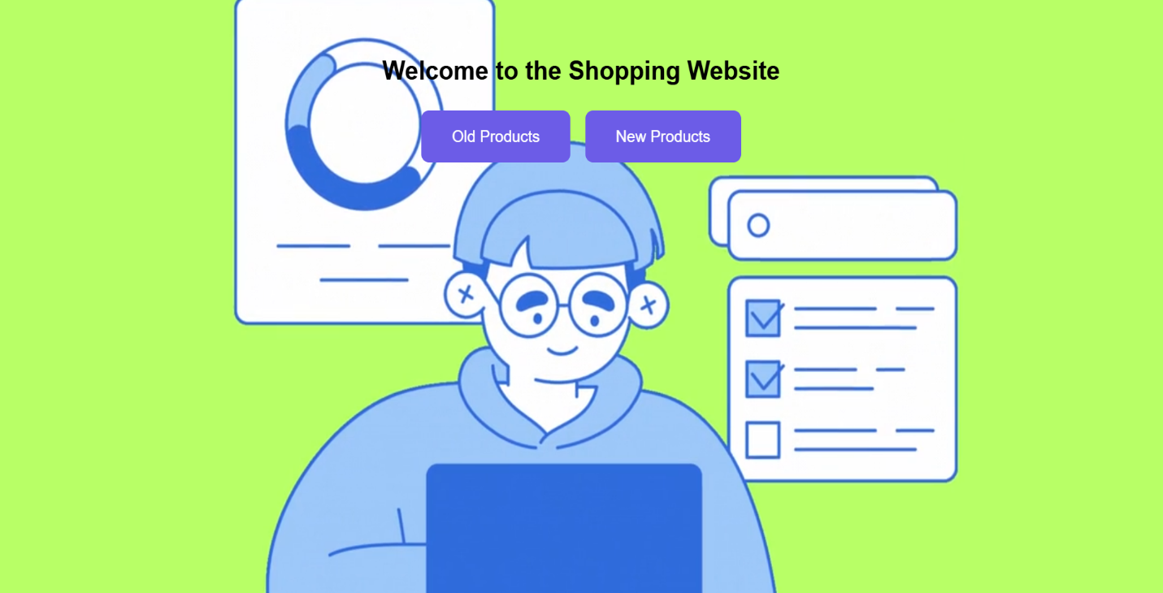

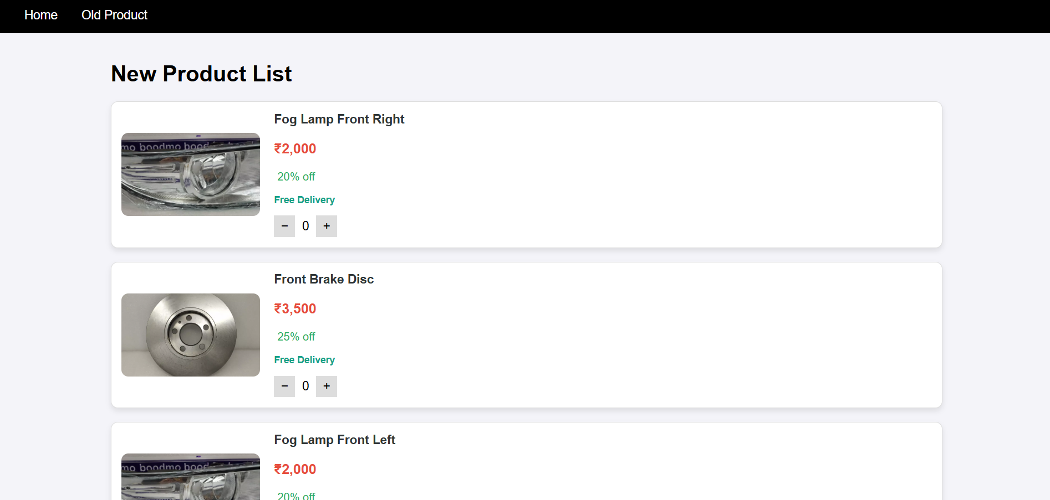

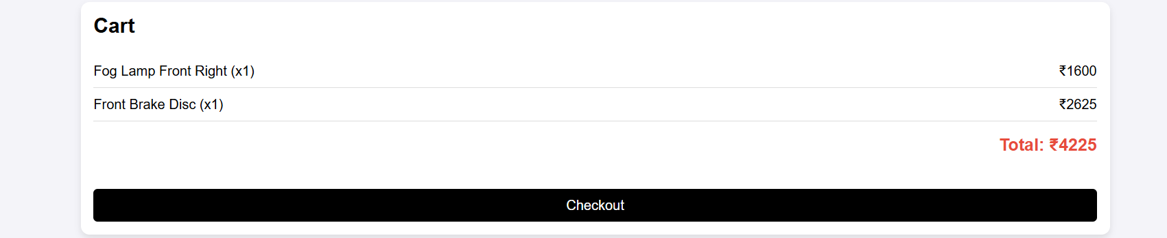

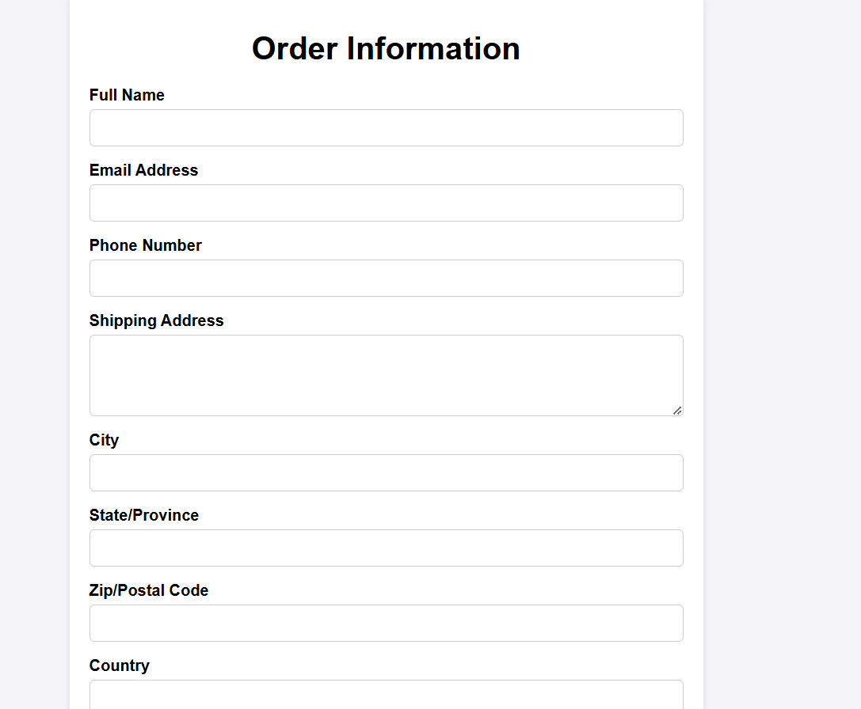

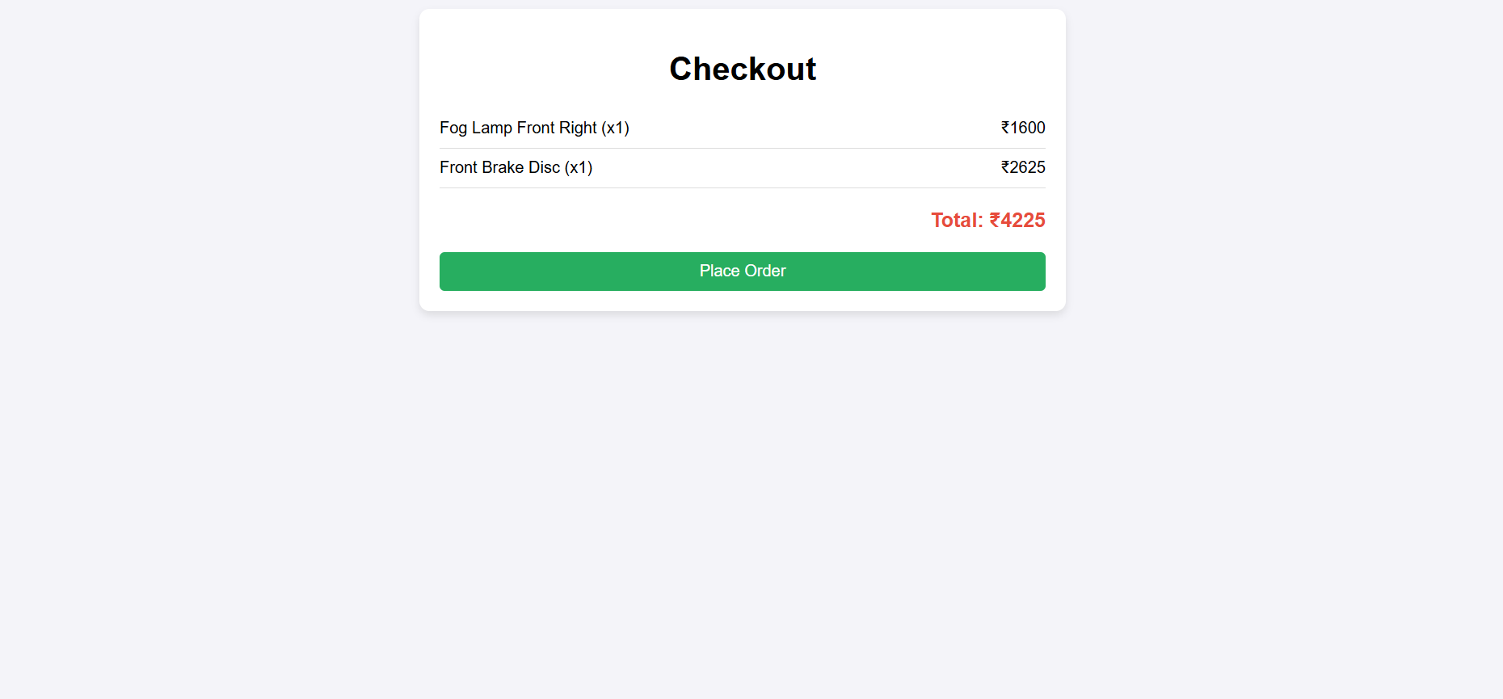

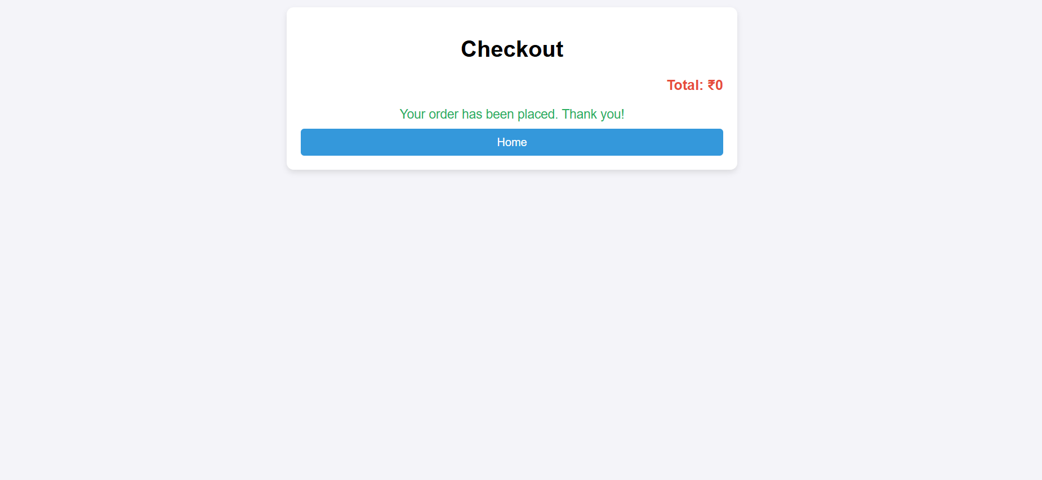

**14. CONCLUSION**

**The extended documentation of the Shopping Website Project outlines a holistic and methodical approach to building a modern e-commerce platform. It reflects a deep commitment to addressing current market needs while proactively anticipating future trends, ensuring that the platform remains robust, secure, and user-centric. The project's modular design not only simplifies maintenance and scalability but also supports the integration of new features as the digital landscape evolves. Rigorous testing methodologies and strategic deployment practices have been integral in ensuring a reliable and high-performance system. Collectively, these efforts position the platform for long-term success, adaptability, and sustained growth in the competitive world of online retail.**